Housing Strategies and Actions

Zoning Strategies

Strategy 1. Update the Title 17 to make it more usable by the city, easier to understand by the public, and add more flexibility for development and uses.

Lead: Planning Department, Planning Commission | Timeframe: Medium-Term | Investment: $$$$ | Effort: High
Objectives: Supply | Anti-Displacement | Affordability | Aging in Place | Accessibility | Variety
Building dimensional standards should be updated to provide more flexibility in development. Reductions to existing lot dimensions and front, side, street side yard, and rear setbacks for residential zones can encourage gentle density. Simplifications to those development standards with the different zones would be more accessible to private and commercial developers, and allow for property owners to incorporate additional dwelling units more easily. Ways to update the code to be more user-friendly include:
  - Consolidate the Suburban Residential, Residential-Duplex, and Manufactured Home districts into one Medium-Density zoning designation that facilities missing middle housing types.
  - Adjust minimum lot size requirements in residential zones.
  - Reduce conditional use permit requirements in residential zones where appropriate.
  - Adopt density bonuses and incentives for building multifamily housing.
  - Update the development regulations and create accompanying graphics for simplicity and use in engagement efforts.
  - Outright permit accessory dwelling units across all residential zones.
  - Upzone permitted residential uses where appropriate, such as permitting clustered housing in the Suburban Residential zone or a new consolidated medium-density zone.
The Kettle Falls Planning Commission is currently working through a proposal to amend the residential zones in Title 17 Zoning of the Kettle Falls Municipal Code (KFMC), and reductions to and a simplification of development standards within those zones, as well an updated Use Classifications table to allow ADUs, cluster housing, and duplexes within additional zones, will facilitate and incentivize affordable housing development.

Strategy 2. Update the city’s permitted use table to clarify and enable innovative housing types, and increase the range of missing middle housing.

Lead: Planning Department, Planning Commission | Timeframe: Medium-Term | Investment: $$ | Effort: High Objectives: Supply | Anti-Displacement | Affordability | Aging in Place | Accessibility | Variety
Enabling creative housing types and densities will more fully meet the needs of residents and community members. The large majority of households in Kettle Falls (76 percent) are one to two people. However, only 46 percent of housing units have one or two bedrooms, and more than half of housing units have three or more bedrooms. An increase of multifamily, attached, smaller lot units, and homes with smaller square footages in general, would better suit aging seniors and other households that don’t want or can’t afford to maintain a large house with property. Dimensional standards for form and intensity in residential zones can be adjusted to improve the physical and economic feasibility of building smaller homes and moderate-density multifamily housing. Density bonuses can allow for a higher number of units than typical for the zone, and to permit ADUs to increase lot minimum standards when design criteria are met, such as a covered porch or entry, covered parking, or material accents. Community engagement also indicated that many residents in Kettle Falls would prefer a gentle increase to density, with accessory dwelling units, duplexes, and mixed-use buildings. Details on the most some possible types are as follows:

Middle Housing Definitions
Accessory Dwelling Units are small attached or detached units that are on the same property as a primary housing structure. They create new housing opportunities while respecting the look and scale of single-dwelling development. ADUs provide a mix of housing to support a variety of housing needs. For example, they provide a means for residents, particularly seniors, single parents, and families with grown children, to remain in their homes and neighborhoods, and obtain extra income, security, companionship, and care.
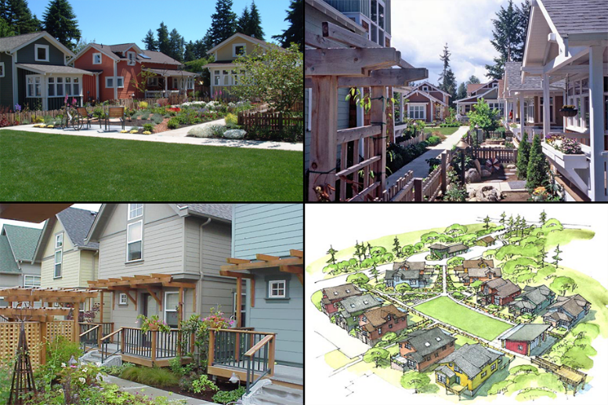
Cottage housing is a mildly dense, small scale housing form. Units are typically built at or below 1,200 square feet with modest dimensions. By design, cottage housing is geared toward single-family tenancy and can be constructed as either attached or detached units. Cottage housing units are built around concepts of shared space and community, requiring a common courtyard or main area, but with a degree of privacy and independence for each household.
Townhomes are developments of at least three single-family units that extend from foundation to roof and have a public yard or right-of-way on not less than two sides that extend at least 50% of the length of each of the two sides. These provide more affordable options for moderate-income families and allow a more moderate density of housing units than single-family homes.
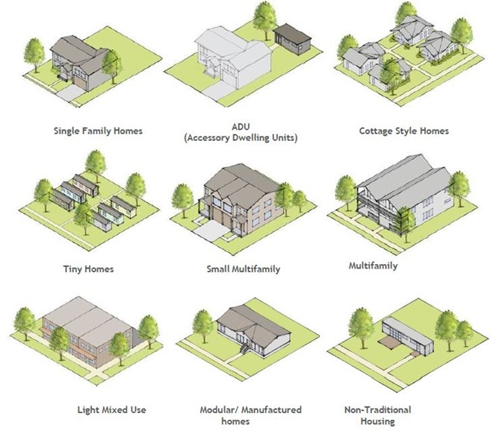
Senior and Assisted Living Facilities include a range of housing types, such as a 55+ community, a retirement home, a senior housing co-op, assisted living facilities, or nursing homes.
Other middle housing types may be added as well, at the city’s discretion. The goal of providing a range of housing types goes beyond the three described here. Many others are popular in housing discussions, such as tiny homes, mixed use, modular, manufactured, and non-traditional housing types such as shipping containers. See Figure X for some examples, and the Missing Middle Housing website for more information.

Strategy 3. Adjust zoning development standards to reduce barriers to thousing production, and to ensure new developments of additional housing types are integrated appropriately.

Lead: Planning Department, Planning Commission | Timeframe: Medium-Term | Investment: $$ | Effort: Moderate
Objectives: Supply | Anti-Displacement | Affordability | Accessibility | Variety
Tiny homes, which are typically no more than 400 square feet and can be either built on foundations or on wheels, can provide a housing option for individuals and households who desire privacy, but do not want or cannot afford a large single-family home. They can also be used as a way of providing housing for people experiencing homelessness. Until recently, state law, building codes, and local regulations have presented numerous legal and logistical barriers to siting and building these very small, detached dwellings.

In 2019, the state legislature passed Senate Bill 5383, which updated state law to enable the development of tiny house villages or communities throughout the state. This law defined tiny houses and directed the adoption of the updated residential building code. The City of Kettle Falls can do the following to study and improve its code and policies on tiny houses.
- Create permit pathway for Planned Development (KFMC 17.05.060) to allow siting of tiny homes (similar to manufactured home park) and more flexibility for homes with smaller footprints.
- Consider modifying the use matrices to specify where tiny houses or tiny house villages would be permitted or conditionally allowed (see Strategy 2).
- Add definitions for tiny houses to KFMC 17.01.042 to differentiate trailers, manufactured homes, and recreational vehicles. This includes clarifying that only tiny houses on foundations (not on wheels) are allowed as ADUs.
- Include support for tiny houses in housing element of Comprehensive Plan.
- Adopt updated International Residential Code (IRC) with Appendix Q modified to include tiny houses.
- Update site plan approval criteria to account for unique site needs of tiny houses (e.g., water/sewer hookups, gravel/concrete pad, location, etc.), especially to differentiate tiny homes on wheels (THOWs) from ADU requirements.

Land Use and Infrastructure Strategies

Strategy 4. Continue efforts to upgrade water and sewer infrastructure to reduce barriers to serving new development.

Lead: Public Works, Planning Department | Timeframe: Medium-Term | Investment: $$$ | Effort: Moderate
Objectives: Supply | Anti-Displacement | Affordability | Aging in Place | Accessibility | Variety
The capacity of the water and sewer systems in Kettle Falls is sufficient for projected growth. Given that the city is experiencing housing growth on county land, outside of city limits, water supply and treatment will affect future growth. The city’s well system is unlikely to be sufficient for continued growth, as the water levels reached near-critical points during the 2021 heat wave. The water system is sourced from wells that are located approximately one mile from Kettle Falls, which creates increased costs to infrastructure maintenance, and the sewer system will require regular replacement of outdated pipes. While water rights within the city are complicated, funding solutions and partnerships should be explored to ensure that service levels are adequate for new development.

Strategy 5. Analyze usability of Urban Growth Areas (UGAs) and determine if they need to be exchanged for other lands around the city limits; partner with the county to implement UGA changes.

Lead: Planning Department, Planning Commission | Timeframe: Long-Term | Investment: $$$ | Effort: High
Objectives: Supply | Anti-Displacement | Affordability | Aging in Place | Accessibility | Variety
There have been challenges regarding the UGA expansion. Over 100 acres within the UGA are estimated to be unbuildable due to the railroad location. There are floodplain areas that prevent the Urban Growth Boundary from extending farther to the south due to the county’s conservancy designations beyond Evergreen Drive. Stevens County has faced political challenges regarding growth management, which has hindered the ability of Kettle Falls to grow through increased density, rather than sprawl. The disconnect between opportunities and realistically buildable land has created an inefficient use of city services (e.g., water).
The city should complete a land quantity analysis which includes the UGA to better understand useable lots and those prohibited due to critical areas, the railroad, and other limiting factors. Utilizing this information, the city should work with the county to perform a UGA swap of the unusable lands while proposing an exchange of UGA parcels and/or areas of the UGA.

Strategy 6. Update off-street parking regulations for consistency with Housing Needs Assessment (HNA) findings. Reduce parking minimums for historic Kettle Falls and include strategies to update and/or remove additional parking requirements when structures are changed. Consider additional parking strategies to promote mixed-use development.

Lead: Planning Department, Planning Commission | Timeframe: Med-Term | Investment: $$ | Effort: Moderate
Objectives: Supply | Anti-Displacement | Affordability | Aging in Place | Accessibility | Variety
Parking minimums have negatively affected housing affordability and development, historic preservation, the environment, small businesses, walkability, and city budgets. The adjustment of off-street parking requirements to a per-bedroom standard is recommended rather than per unit. Minimum requirement reductions would enable flexibility for changes of use to structures in historic Kettle Falls, as well as allow for revitalization and mixed-use development in other areas of the city, which will attract visitors and developers. By reducing the minimum amount of off-street parking spaces required per bedroom, property owners and developers will have more flexibility to provide middle-housing types, while allowing the market to determine the number of spaces needed to meet demands for residents and businesses.

Strategy 7. Dedicate city resources to pursue funding opportunities.

Lead: Planning Department, Administrative Staff| Timeframe: Med-Term | Investment: $$ | Effort: Moderate
Objectives: Supply | Anti-Displacement | Affordability | Aging in Place | Accessibility | Variety
Budget annually to commit city resources to pursue grants that assist with senior/assisted housing and affordable housing development. Some funding opportunities to regularly check on include:
- Consolidated Homeless Grant (CHG)
- Emergency Solutions Grant (ESG)
- Continuum of Care Program
- USDA Rural Development Single Family Housing Repair Loans & Grants
- Community Development Block Grant (CDBG) Program
- HOME Investment Partnership (HOME) Program
- Housing Trust Fund
- Washington Homeowner Assistance Fund
- Washington Trust for Historic Preservation

Code and Policy Strategies

Strategy 8. Integrate displacement into the analysis and review of potential policies, programs, and development applications by creating a standardized assessment of potential unintended consequences upfront, and enforcing reasonable mitigation efforts directly connected to the proposal.

Lead: Planning Department, Planning Commission | Timeframe: Long-Term | Investment: $ | Effort: Low
Supply | Anti-Displacement | Affordability | Aging in Place | Accessibility | Variety
Displacement occurs when households are involuntarily forced to relocate due to factors such as evictions, increased housing costs, or redevelopment. Given that Kettle Falls is a relatively low-income community, and the aging condition of homes in the city, it is critical to minimize the potential for physical, economic, and cultural displacement of existing residents. Review of policies, programs, and development applications is recommended to create a standardized assessment of potential displacement, and identify efforts to directly minimize the risks. Proactive risk assessment, combined with the development of middle-housing types that can serve as affordable, attainable solutions--whether temporary, transitional, or permanent--will help to preserve the community and its character.

Strategy 9. Evaluate potential building code amendments to provide more feasibility for mixed-use development and small apartments, and for rehabilitation of older buildings.

Lead: Planning Department, Building Department/Official | Timeframe: Mid-Term | Investment: $$ | Effort: Moderate
Supply | Anti-Displacement | Affordability | Aging in Place | Accessibility | Variety
Historic Kettle Falls lacks vitality, and the building code has created barriers to the incorporation of mixed-use buildings and the renovation or rehabilitation of older buildings. It is recommended to define and permit mixed-use development in commercial corridors and main streets under Chapter 15.04 Building Code. An allowance for smaller apartments (e.g., 3-5 units) to be built under the International Residential Code (IRC) as opposed to the International Building Code (IBC) would provide significant reductions to development costs.

Strategy 10. Develop code enforcement educational materials for the public to utilize.

Lead: City | Timeframe: Short-Term | Investment: $ | Effort: Low
Supply | Anti-Displacement | Affordability | Aging in Place | Accessibility | Variety
Residents have voiced dissatisfaction about code noncompliance (i.e., junk cars, unkempt yards, etc.). The development of educational materials for the public can create improved compliance with the overall quality of homes and neighborhoods in Kettle Falls. Longer-term, the city may consider hiring a code enforcement officer, or partnering with a local housing provider to ensure that existing housing stock is well-maintained. Enforcement can lead to displacement when major upgrades and repairs are made. Where possible, consider a phased enforcement approach and allow landlords the flexibility to make improvements over time that do not require the displacement of current residents.

Strategy 11. Produce educational materials, such as a one-page how-to document for all land use permit applications, and flow charts for each permit type (I, II, III). Provide this information as a reference document for the public/developers to easily use.

Lead: City | Timeframe: Medium-Term | Investment: $$$ | Effort: Moderate
Supply | Anti-Displacement | Affordability | Aging in Place | Accessibility | Variety
Educational materials for all land use permit applications and permit types should be produced so that this information is readily available for developers and/or residents to have when they speak to planning about land use changes. The information creates consistency in the information that is shared with the public and can provide code references for further information. Following the update of Title 17, the city planner or planning commission should produce the educational materials by utilizing the new municipal code.

